Student Name: Lewis J Feik
Date: January 31, 2026
Assignment: Week 3 Lab: Establishing Network Baselines

Part A — Open PCAP Files
Instructions: Successfully open each PCAP in Wireshark.
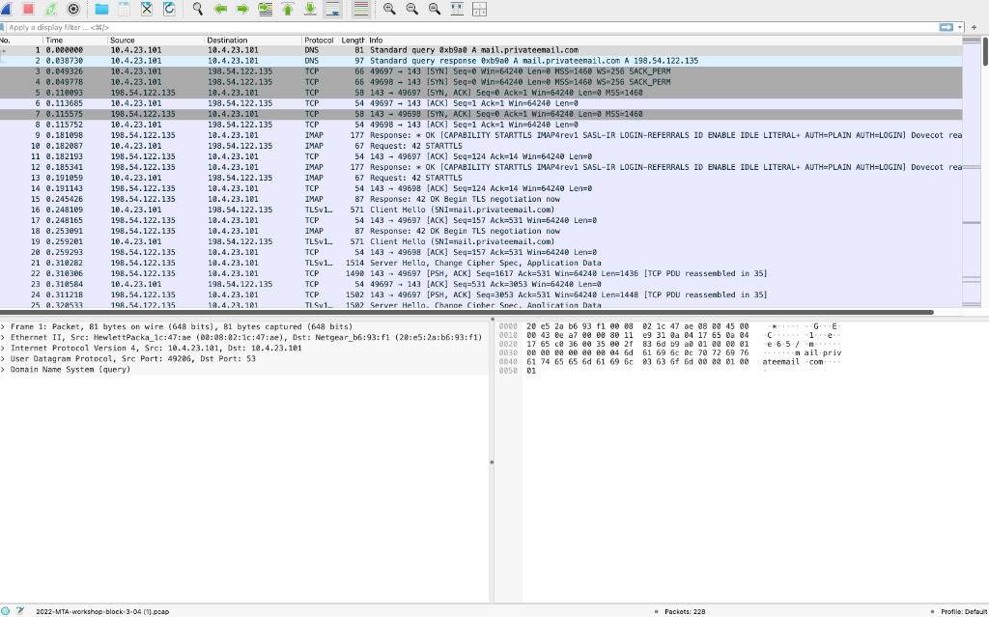

Part B — Initial Observation
Instructions: Observe traffic without filters. Identify common protocols and communication patterns.
Traffic Analysis & Communication Patterns:
The captured traffic displays a sequential connection flow initiated by a local client (10.4.23.101) communicating with an external server (198.54.122.135). The communication pattern represents an automated email retrieval session where the client resolves the server address, establishes a connection, and immediately negotiates an encrypted tunnel.
Common Protocols Identified:
- DNS (Domain Name System):
  - Observed in Packets: 1–2
  - Explanation: DNS translates human-readable domain names into IP addresses. In this capture, the client requests the IP address for the domain mail.privateemail.com before initiating a connection.
- TCP (Transmission Control Protocol):
  - Observed in Packets: 3–8
  - Explanation: TCP provides reliable, ordered, and error-checked delivery of data. The capture shows a standard "three-way handshake" (SYN, SYN-ACK, ACK) on port 143 to establish a session between the client and the mail server.
- IMAP (Internet Message Access Protocol):
  - Observed in Packets: 9–10, 12
  - Explanation: IMAP is a standard email protocol used to retrieve messages from a mail server. The traffic shows the server identifying itself (Dovecot) and the client issuing a STARTTLS command to upgrade the connection.
- TLS (Transport Layer Security):
  - Observed in Packets: 16–25
  - Explanation: TLS is a cryptographic protocol designed to provide communications security. Following the IMAP STARTTLS request, the protocol switches to TLS (Client Hello/Server Hello) to encrypt the remainder of the session.

Part C — Filtering
Instructions: Apply at least three display filters per PCAP. Identify the filters used and provide a reason for using that filter.
Filter 1: dns
- Reason: I applied this filter to isolate the initial network request. This allowed me to confirm exactly which domain the client was attempting to resolve (mail.privateemail.com) prior to any data exchange, verifying the intent of the connection.
Filter 2: tcp.port == 143
- Reason: Port 143 is the default non-encrypted port for IMAP. Filtering by this port allowed me to view the specific application handshake and the cleartext negotiation commands (like STARTTLS) without the visual noise of unrelated background network traffic.
Filter 3: tls
- Reason: I used this filter to verify that the security upgrade was successful. It confirms that after the initial handshake, the traffic successfully transitioned to an encrypted state ("Client Hello," "Change Cipher Spec"), ensuring credentials were not passed in cleartext.

Part D — Baseline Identification
Instructions: Identify patterns consistent across multiple PCAPs and explain why traffic is considered normal.
Identified Pattern:
The traffic follows a strict, consistent behavioral pattern: Resolution $\rightarrow$ Connection $\rightarrow$ Negotiation $\rightarrow$ Encryption.
- Resolution: The client performs a DNS lookup.
- Connection: A TCP connection is established on Port 143.
- Negotiation: The client requests STARTTLS immediately upon connecting.
- Encryption: The session upgrades to TLS.
Why this is considered "Normal":
This traffic is considered a normal baseline for email activity because it follows standard RFC compliance for secure email retrieval. The client does not attempt to scan multiple ports (reconnaissance) or fail multiple login attempts (brute force). Instead, it efficiently connects and immediately prioritizes security by upgrading to an encrypted channel, which is the expected behavior for a properly configured email client.

Part E — Analyst Reflection
Instructions: Explain why baselines are critical to security investigations.
Establishing a network baseline is the single most critical step in security analysis because it defines the standard for "known-good" behavior within an environment. Without a comprehensive understanding of what normal traffic looks like—such as standard DNS lookups or routine IMAP connections—an analyst cannot accurately identify anomalies or malicious deviations. Baselines allow security teams to tune out the vast volume of legitimate background noise, effectively reducing false positives and alert fatigue. For example, knowing that a specific server normally communicates only on port 143 allows an analyst to instantly spot a red flag if that same server suddenly transmits data on port 4444. Ultimately, baselines provide the necessary context that transforms raw data into actionable intelligence, allowing investigators to focus their limited resources on genuine threats.

